Name
Institutional Affiliation
Date

The relationship that has been showcased by the pressure and volume is that the pressure tends to increase as the volume of the container decreases. This is what is stated by Boyle's law
The absolute pressure that is exerted by the mass of the ideal gas shows that it is inversely proportional to the volume of the container if the temperature and the gas are kept to be constant in a particular closed system.
The purpose of the experiment is to know the relationship that exists with the pressure with volume. This is normally carried out with an ideal gas. The first part of the experiment is to verify the Ideal Gas Law and the second part is to know the absolute zero of the Universal Constant Gas. The Universal gas that is referred to in this experiment is the one that obeys the Ideal Gas Law which is given by PV = nRT. In this particular case P represent that absolute pressure, V represents the volume regarding meters cubed and n is the number of the moles of the gas and the T represents that temperature that is normally kept at a constant regarding Kelvin< R is the universal gas (Chalmers, 12).
The part one of the experiment is to verify the relationship that exists between the pressure and the ideal gas. The values that are obtained are then used to compare and predict the relationship that exists between the pressure and the volume (Chalmers, 23).

Materials

Computer
Vernier Gas Pressure Sensor
Vernier computer interface (Lab Pro)
20 mL gas syringe
Vernier Logger Pro software
- Methods
1. By the use of the MEID username and password, the computer is logged in, and the verification that is done is to make sure that the computer is logged in by the use of the MEID username and password.
2. The Logger Pro Software and the Boyle’s Law Lab file is then opened by the use of the Vernier.

- The pressure is then changed from the kPa to atm.
- The position of the syringe piston of the syringe is the fit well so that the volume of the trapped air is measured within the barrel.
- The syringe is then connected to the Gas Pressure Sensor Press.
- The air in the syringe is then allowed to equilibrate with the Gas Pressure Sensor for about a minute.
- The piston of the syringe is then moved by 2ML to the larger volume, and when the pressure is stable, the blue button is pressed.
- The pressure of the gas in the syringe is measured in different volumes.
- All the data are then collected.
2. Data
1. One of the factors that are used in the experiment to determine the relationship of the pressure and the volume is the proportionality constant which is K for that matter. This helps in finding whether the relationship between the two is inverse of directly proportional. If the relationship between the two is inverse, therefore, k = P * V.
The graph that is obtained through the collected data is curved. This also marks the relationship between the pressure and the volume. For one to create a graph of a straight line, a column of 1/v has to be created.
2. A graph of pressure vs. 1/V is obtained to be of a straight line
4. The gradient of the graph is then plotted, and the gradient that is obtained from the graph is equivalent to the proportionality constant with is K for that matter.

3. Insert a new graph of Pressure vs. 1/Volume. Make sure that the new graph has an appropriate title, and that 1/V is being plotted along the x-axis and Pressure is being plotted along the y-axis.

The experimental factors that are assumed in this experiment are that temperature and the moles that males up the gas are constant.
The most significant error source in the experiment is holding the syringe at the same place while the process of the data collection thus there was no accurate reading of the syringe.
The data that is obtained in the calculated columns of the P * V and P / V. The relationship should show the constant value of proportionality at all areas. The relationship should show a given level of values.
Results

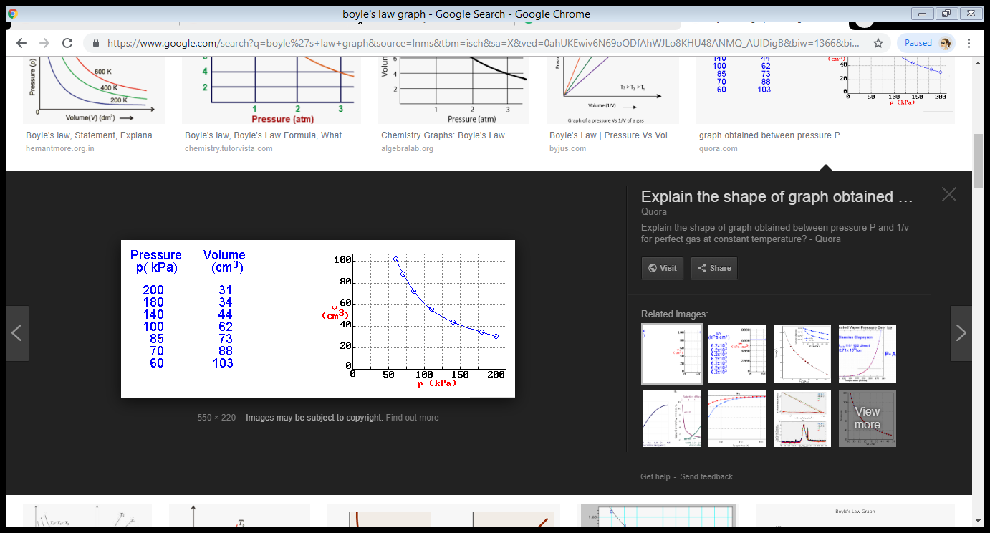

References
Chalmers, A. (1999). Making sense of laws of physics. In Causation and laws of nature (pp. 3-16). Springer, Dordrecht.

